**Same Old Shit Mirror Wall Art**

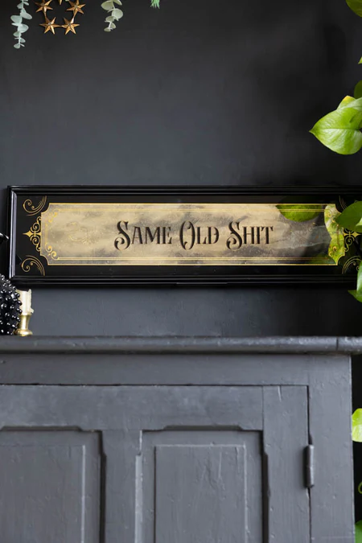The **Same Old Shit Mirror Wall Art** brings a bold and humorous twist to your interior decor. Featuring a sleek, reflective surface, this piece is not just a mirror, but a statement. The phrase "Same Old Shit" is playfully displayed, offering a dose of wit and sarcasm for those with a sense of humor. Perfect for modern, eclectic, or minimalist spaces, this mirror adds a touch of personality and attitude. Whether in a bedroom, living room, or office, it serves as both a functional mirror and a conversation starter, combining style with a playful edge.